**Practical No 3: Demonstrate various CSS Features**

**<!DOCTYPE html>**

**<html>**

**<head>**

**<link rel="stylesheet" href="login.css">**

**<title> CSS Login Screen Tutorial </title>**

**</head>**

**<body>**

**<body>**

**<div class="login-page">**

**<div class="form">**

**<div class="login">**

**<div class="login-header">**

**<h3>LOGIN</h3>**

**<p>Please enter your credentials to login.</p>**

**</div>**

**</div>**

**<form class="login-form">**

**<input type="text" placeholder="username"/>**

**<input type="password" placeholder="password"/>**

**<button>login</button>**

**<p class="message">Not registered? <a href="#">Create an account</a></p>**

**</form>**

**</div>**

**</div>**

**</body>**

**</body>**

**</html>**

**Save below program file with name- login.css**

**@import url(https://fonts.googleapis.com/css?family=Roboto:300);**

**header .header{**

**background-color: #fff;**

**height: 45px;**

**}**

**header a img{**

**width: 134px;**

**margin-top: 4px;**

**}**

**.login-page {**

**width: 360px;**

**padding: 8% 0 0;**

**margin: auto;**

**}**

**.login-page .form .login{**

**margin-top: -31px;**

**margin-bottom: 26px;**

**}**

**.form {**

**position: relative;**

**z-index: 1;**

**background: #FFFFFF;**

**max-width: 360px;**

**margin: 0 auto 100px;**

**padding: 45px;**

**text-align: center;**

**box-shadow: 0 0 20px 0 rgba(0, 0, 0, 0.2), 0 5px 5px 0 rgba(0, 0, 0, 0.24);**

**}**

**.form input {**

**font-family: "Roboto", sans-serif;**

**outline: 0;**

**background: #f2f2f2;**

**width: 100%;**

**border: 0;**

**margin: 0 0 15px;**

**padding: 15px;**

**box-sizing: border-box;**

**font-size: 14px;**

**}**

**.form button {**

**font-family: "Roboto", sans-serif;**

**text-transform: uppercase;**

**outline: 0;**

**background-color: #328f8a;**

**background-image: linear-gradient(45deg,#328f8a,#08ac4b);**

**width: 100%;**

**border: 0;**

**padding: 15px;**

**color: #FFFFFF;**

**font-size: 14px;**

**-webkit-transition: all 0.3 ease;**

**transition: all 0.3 ease;**

**cursor: pointer;**

**}**

**.form .message {**

**margin: 15px 0 0;**

**color: #b3b3b3;**

**font-size: 12px;**

**}**

**.form .message a {**

**color: #4CAF50;**

**text-decoration: none;**

**}**

**.container {**

**position: relative;**

**z-index: 1;**

**max-width: 300px;**

**margin: 0 auto;**

**}**

**body {**

**background-color: #328f8a;**

**background-image: linear-gradient(45deg,#328f8a,#08ac4b);**

**font-family: "Roboto", sans-serif;**

**-webkit-font-smoothing: antialiased;**

**-moz-osx-font-smoothing: grayscale;**

**}**

**<form class="login-form">**

**<input type="text" placeholder="username"/>**

**<input type="password" placeholder="password"/>**

**<button>login</button>**

**<p class="message">Not registered? <a href="#">Create an account</a></p>**

**</form>**

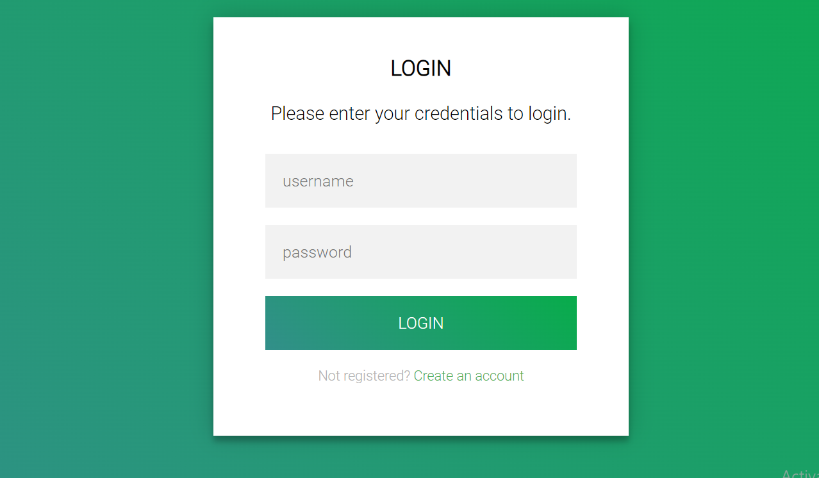**output:**